Đau đầu quá, với lại computerome dường như ko hoạt động, nên ngồi đọc lý thuyết. Note lại một số thông tin

- in the 19th century, Gregor Mendel observed that units of inheritance are discrete
- A gene is defined ad a DNA segment whose information is expressed either as an RNA molecule or as a polypeptide chain (after translation of mRNA)
- Genes usually are found at defined positions on a chromosome, and such a position may be referred to as a locus (A locus may correspond to a gene, but there are some loci that are not genes).
- Gene are identified biologically (in lab) when a mutation occurs that alters a phenotpe or character.
- character = property of an organism that can be observed or measured
- phenotpe = particular state of a character
- normal gene = wild-type gene
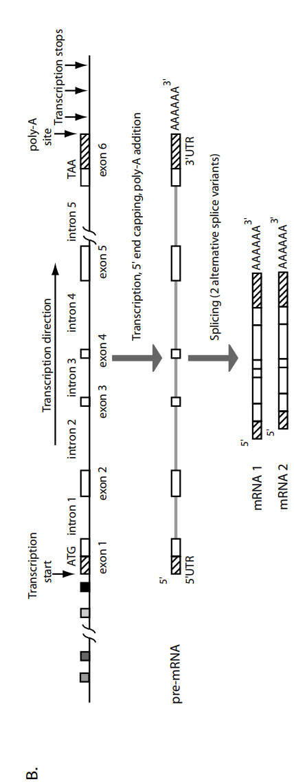
- a given gene, corresponding to a particular locus, may have alternative forms called alleles
- alleles differ in DNA sequences and these differences lead to differences in amino acid sequence
- DNA strand whose sequence corresponds to an mRNA is called the coding strand
- The DNA strand that is complementary to the mRNA is called the template strand
- Eukaryotic genes are much more complicated than prokaryotic genes. They contain exons,which are segments that are represented in the processed mRNA
- initial transcript = primary transcript = pre-mRNA
- Eukaryotic genes have more extensive control regions that include binding sites for transcription factors and enhancer sequences (that together regulate the level of transcription) and the “core” promoter where the transcription complex assembles.
- Intron can be very long and present in DNA and pre-mRNA

- Grey boxed in the image above are transcription binding sites, upstream of the promoter.
- The gene illustrated contains 6 exons and 5 introns. Exon 1 and 6 contain regions that will not be translated (5’UTR region in exon 1 and 3’UTR in exon6).
- Transcription does not terminate at a unique position (vertical arrows).
- The immediate product of transcription is a pre-mRNA that is modified at the 5’ and 3’ ends.
- The poly-A tail is added to the end of the message after transcription has occurred.
- Slicing removes the introns to produce mature mRNA specied that are ready for translation
- Alternative splicing may or may not occur, but when it does, a single gene region may be responsible for two or more different (related) polypeptide chains.
- An average human gene is about 27000 bp in extent and contains 9-10 exons of average length 145 bp.
- The rest of the gene region corresponds to extensive control regions, unstranslated regions, and the intronic regions, which may be thousands of base pairs in extent.
- Eukaryotic cells may contain one, two or three types of genomes: the nuclear genome, the mito genome and the chloroplast genome (in plants).

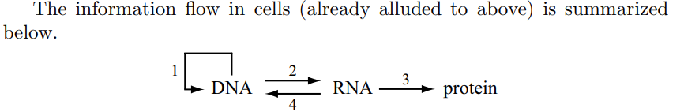
1: DNA replication, where a DNA sequence is copied to yield a molecule nearly identical to the starting molecule
2: Transcription: where a portion of DNA sequence is converted to the corresponding RNA sequence
3: Translation: where the polypeptide sequence corresponding to the mRNA sequence is synthesized
4: Reverse transcription: where the RNA sequence is used as a template for the synthesis of DNA, as in retrovirus replication, pseudogene information, and certain types of transposition.

- Duplex DNA molecular: a DNA with two strands, with default 5’ to 3’ direction and the base-pairing rule

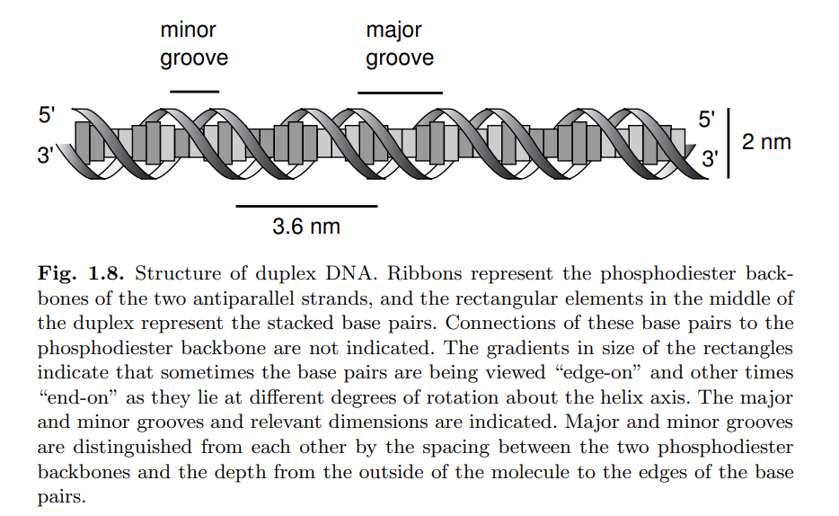

- RNA:
+ Includes A, U, G, C
+ Left-to-right orientation corresponding to the 5’ to 3’.
+ In most case, RNA is encountered as a single strand but often it will form intrastrand base pairs to form secondary structures that may be functionally important.
+ Duplex RNA molecules:
- Can be functional, either as genomes of some virused or as interfering RNA (RNAi) that helps regulate gene expression in plants and animals
+ Size of RNA molecules typically range from around 100 base to a few thousand base (not bp).
+ Where does the translation begin?
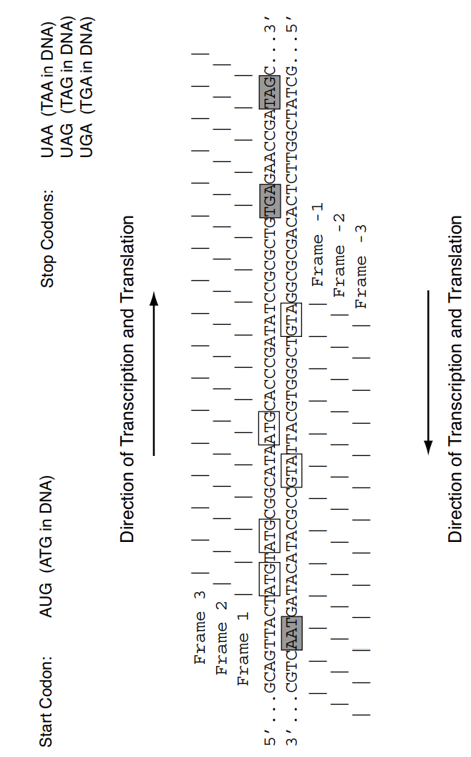
- In prokaryotes: there is a hexanucleotide at the 5-end of the mRNA that sets the stage for translation beginning with the next AUG
- In eukaryotes: there is a 5-cap structure and translation begins at the next AUC of the mRNA
+Open reading frame: is a stretch of DNA sequence that does not contain a stop codon

- PCR: for routine molecular biology procedures, a lab technician requires about 10E-7 to 10E-8 gram of DNA. Because only small quantities of any particular nuclear DNA sequence are isolated directly, DNA is often amplified with PCR method. PCR employs in vitro enzymatic DNA synthesis in repeated cycles, such that if amount A of a DNA is originally present, after n cycles, the amount present will be approximately A.2^n. With extreme care to exclude contaminating DNA, it is technically possible to amplify as little as one molecule by PCR. There is no DNA repair system to correct polymerase copying errors during PCR, consequently, after repeated cycles of amplification, some of the copies will have slightly altered sequences compared with the original, unamplified molecules.

- Cloning = enzymatic joining of the desired DNA sequence to a cloning vector and its progapation in a convenient host organism (bateria, yeast or eukaryotic cells in culture).
- Cloning vector = is a DNA molecule chosen to have approriate replication properties (copy number, control of copy number), insert size, and host specificity (vector must be match to the host cell) for producing the desired amount and length of DNA product.
- If a genome is begin analyzed, genome = collection of clones = library
- Microarray:
+ Studies gene expression
+Focus on types and amounts of difference of RNA species in cells or tissues
+ Mammalian genome: has around 25,000 genes ~ 25000 to 75000 or more possible different mRNA species when alternative splice variants are taken into account.
+Different mRNA species can have different levels of abundance
- mRNA molecules:
+ are often unstable (some may be degraded in vivo within seconds to minutes)
+ sensitive to alkaline hydrolysis
+ stable ribonucleases present in cells ( and on lab machine or fingerprint of techinicians who don’t wear protective gloves) represent an even bigger problem
- cDNA: complementary DNA = produced from in vitro reverse transcription

- How to read a correlation matrix
+ To understand a relationship between 2 variables, one way is to use Pearson correlation coefficient, which is a measurement of linear association between two variables. It has a value between 1 and -1 where:
- 1 indicates a perfectly possitive linear correlation
- -1 indicates a perfectly negative linear correlation
- 0: no linear correlation

+ In some cases, we want to understand the correlation between more than just one pair of variables. In these cases, we can create a correlation matrix which is a square table that shows the correlation coefficients between several variables

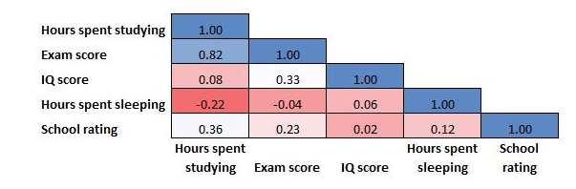
+ Correlation matrix is perfectly symmetrical → can be displayed in half and colored like a heat map

- Application of a correlation matrix
+ Conveniently summarize a dataset

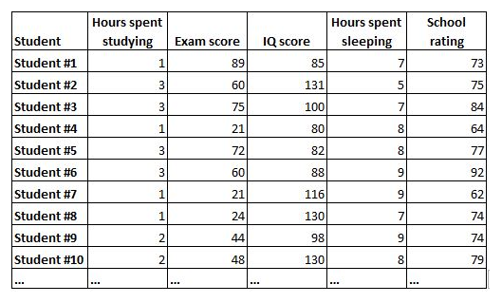

+ Serves as a disgnostic for regression
One key assumption of multiple linear regression is that no independent variable in the model is highly correlated with another variable in the model. When two independent variables are highly correlated, this results in a problem known as multicollinearity and it can make it hard to interpret the results of the regression. One of the easiest way to detect potential multicollinearity problem is to look at a correlation matrix and visually check whether any of the variables are highly correlated with each other.

+ Can be used as input for another analysis

Discuss about correlationPlot using deeptools
https://www.biostars.org/p/9473200/

Một vài điều học được:
- Những vùng mà ko khác biệt nhau giữa các điều kiện: subtelomeres, repeated regions, centomeres… nên tính correlation của các vùng này sẽ cao
- window size lớn, ví dụ 10000 bp, các chip-seq peak sẽ bị bury trong đó nên có thể ko thấy sự khác biệt, dẫn tới correlation cao
- Pearson correlation thì sensitive to outlier trong khi Spearman correlation thì more robust to outlier, nên thử cả hai

